State budget institution of higher education
"Volgograd State Medical University"
Ministry of Health of the Russian Federation
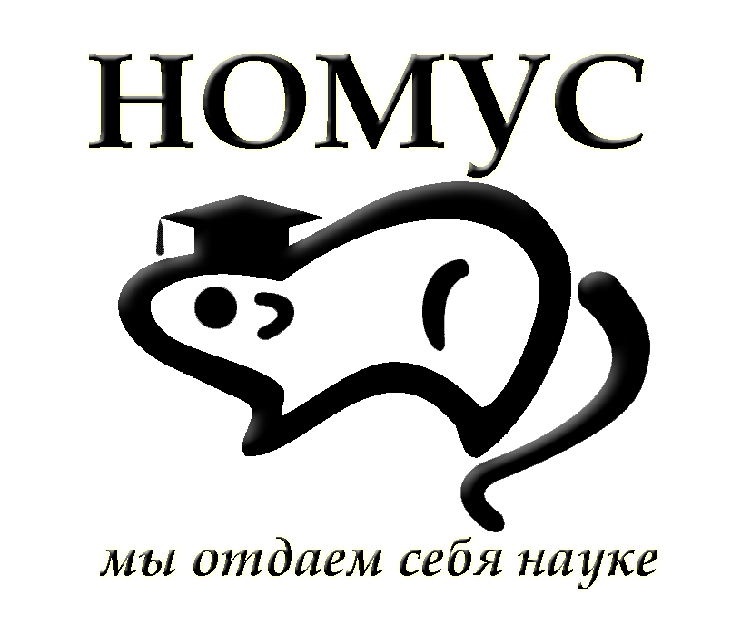
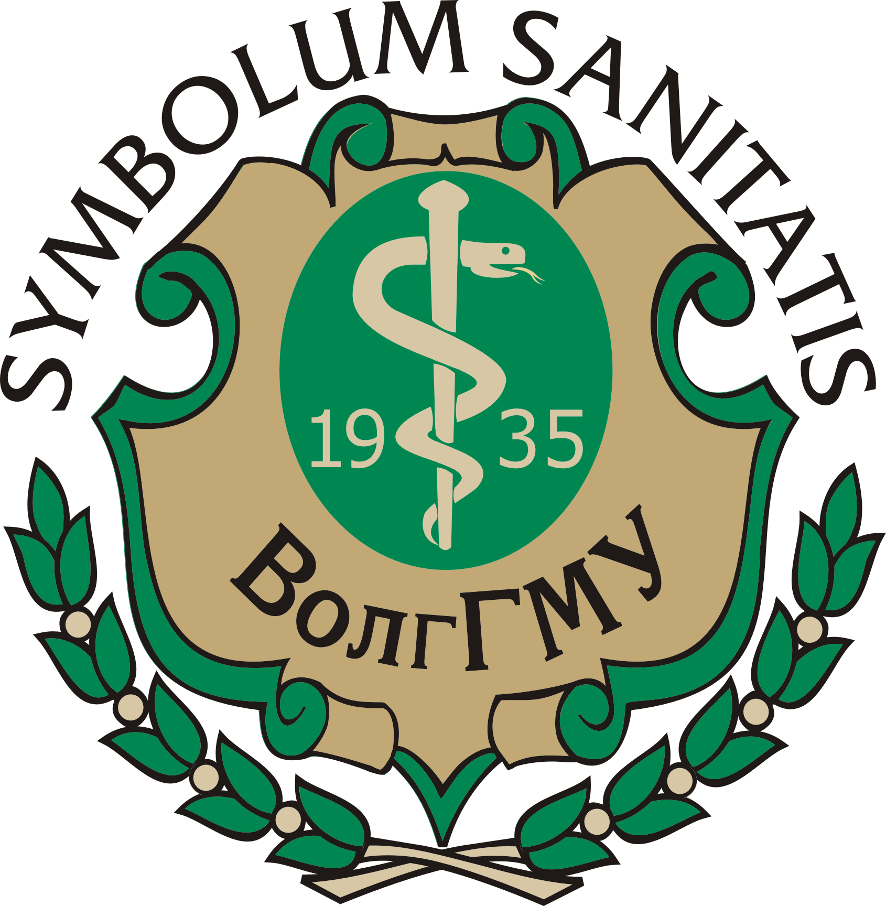
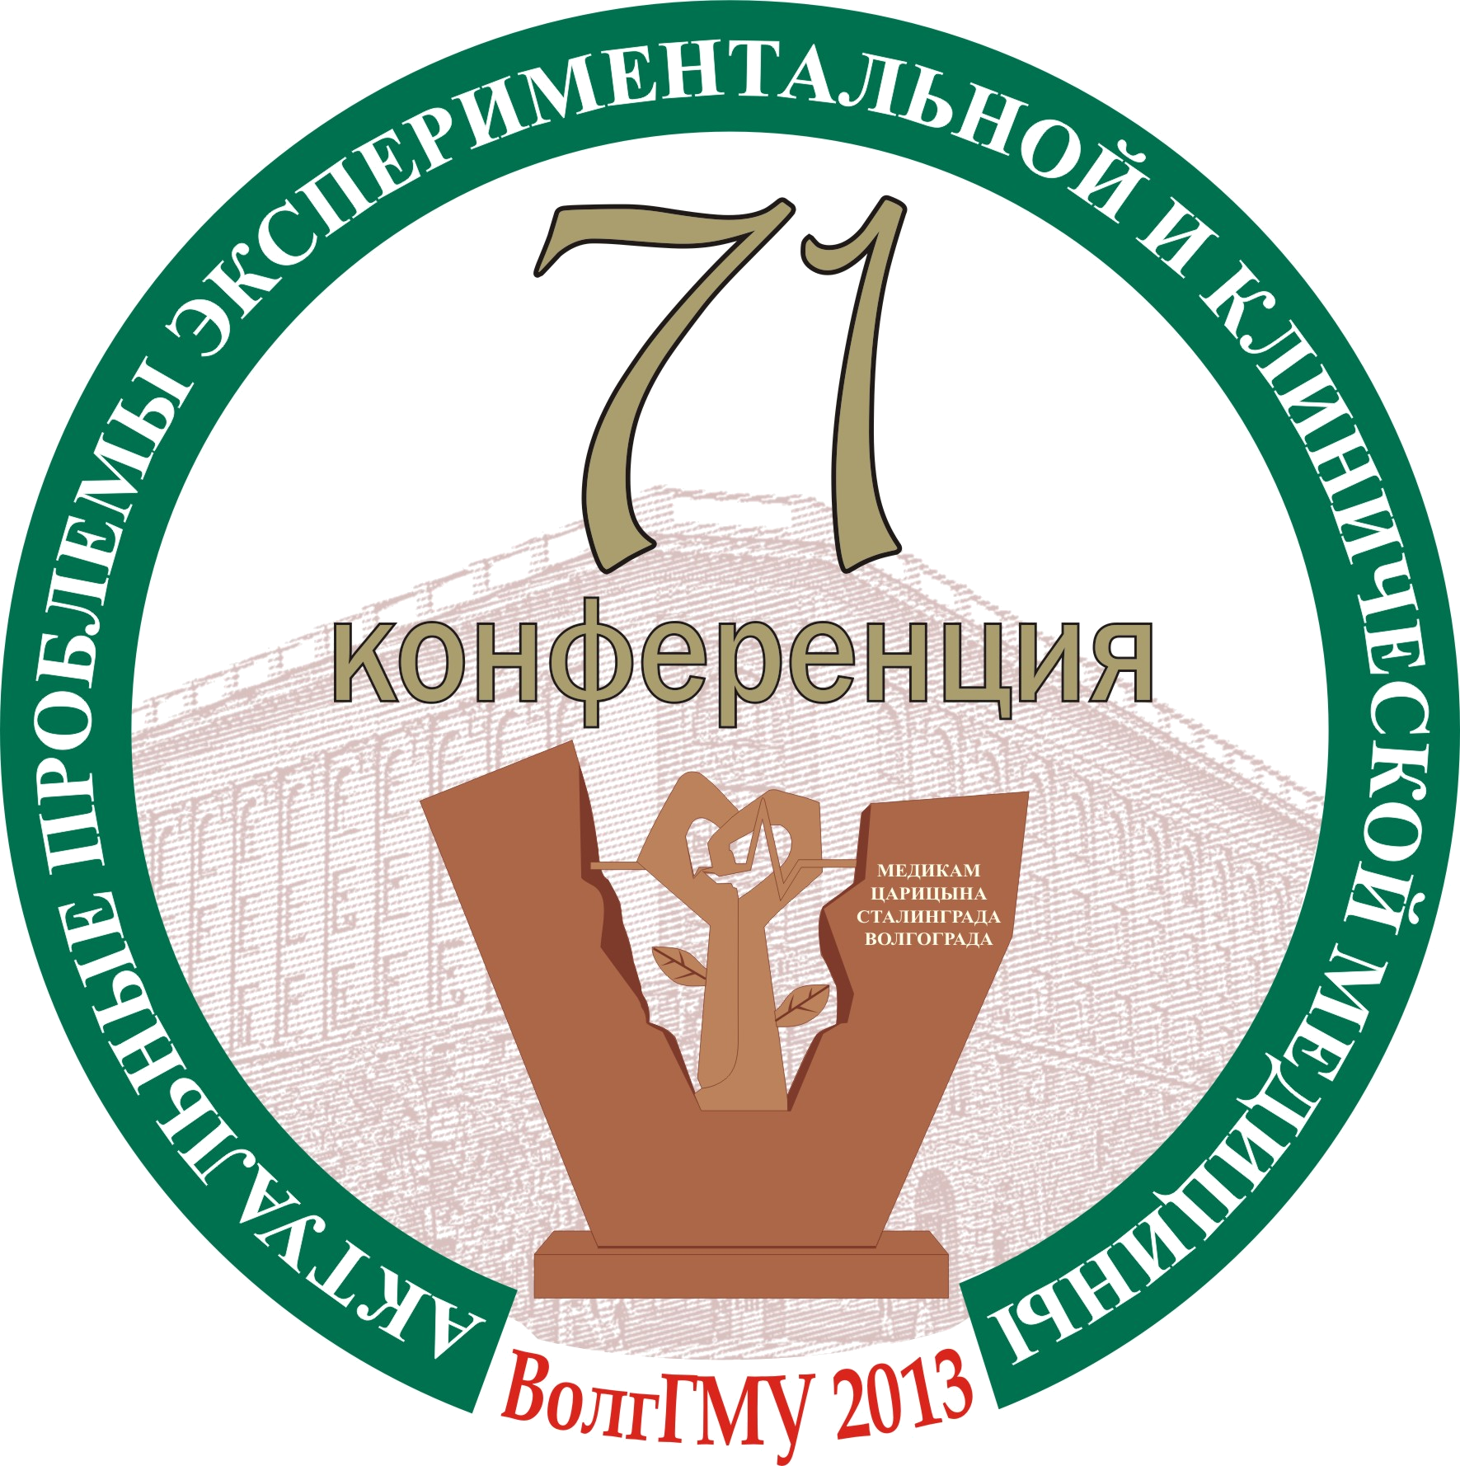

71th Open research conference of young scientists and students
of VolgSMU with international participation

“URGENT PROBLEMS OF EXPERIMENTAL
And Clinical Medicine”

Volgograd, April 24-27, 2013

Dear colleagues!
The Research Society of young scientists and students of the Volgograd State Medical University invites young scientists, students of universities and research institutes from Russia and foreign colleagues to participate in the 71th Open reasearch and practical conference of young scientists and students of VolgSMU with international participation "Urgent Problems of Experimental and Clinical Medicine" on April 24-27, 2013 in the Volgograd State Medical University. Master classes will be held by experts on various topical issues of modern medicine during the conference.

Spheres covered by the conference:

1. Normal physiology.
2. Pathological physiology and experimental pathology.
3. Biomedical chemistry and biophysics.
4. Pediatrics.
5. Neurology, ophthalmology, otorhinolaryngology, psychiatry
6. Surgery, traumatology and orthopedics.
7. Dentistry.
8. Rheumatology.
9. Internal medicine.
10. Clinical and experimental microbiology. Immunology. Infectious diseases.

11. Pharmacology.
12. Clinical pharmacology and intensive care.
13. General patterns of morphogenesis in the norm, pathology & experiment.
14. Obstetrics and gynecology.
15. General hygiene and ecology. Public health.
16. Medicine and sport.
17. Pharmacy.
18. Humanities.
19. Social work and clinical psychology.
20. Emergency medicine.
21. Radiology diagnostics and radiology therapy.

Condition for participation:
Article and application form (two different files in *.doc format) should be submitted by e-mail only: nomus@volgmed.ru by March 1, 2013.

Foreign publications in English are FREE. Transfer and residence at the hostel of Volgograd State Medical University for incoming participants are FREE.

Requirements for publications:
• There are three categories of participation: the works of young scientists, students and school pupils.
• The papers intended to be presented at the conference should not be previously published or submitted for publication in other publications.
• One author may not have more than two papers (the second one is submitted in collaboration with other conference participants)
• Papers must be in English, approximately 2-3 pages of typewritten text (all fields of 2.5 cm size 12 Times New Roman, line spacing - one and a half, use of capital letters is not recommended).
• All abbreviations (excluding units) may be used only after a reference to the full term. Units are given in the International System of Units.
• By sending the paper, the author and scientific adviser send the right to the organizing Committee to moderate the paper.
• If defects are found in the paper (semantic or technical ones) in the process of preparation for printing, it will be withheld from the press.
• The decision to include a collection of papers is taken at a meeting of the Editorial Board.

Structure of the paper:

The initials and surnames of the authors (S. Jobs)
Title of the article (bold)
Organization at which the research is performed (university, department)
Scientific advisor: scientific degree, title, initials and surname
After a string - the text of the paper.
The text should be divided into sections: introduction, objectives, materials and methods, results and discussion, conclusions, references (no more than 10 references, not earlier than 2003).

Use a consistent system of citation in square brackets [00], the serial number quote the corresponding number in the reference list. Links to conference proceedings and unpublished work in print are not allowed.

Requirements for an oral presentation:
An oral report should be accompanied by a presentation made ​​in Power Point format. An oral presentation should not exceed 5 minutes. The official working languages are English and Russian.
All relevant information about the conference is posted at
nomus.volgmed.ru
APPLICATION FORM
71th Open research and practical conference
of young scientists and students of VolgSMU with international participation
"Urgent Problems of Experimental and Clinical Medicine"
About the authors:

for Young Scientists: name, position, college, street address, zip code, phone, e-mail

for students: name, academic group, year, faculty, university, street address, zip code, phone, e-mail

for school pupils: name, with a letter grade, school, district, city, postal address, zip code, phone, e-mail
Title

Information about the scientific advisor (name, position, academic degree)
University, department
Organization address (code, phone, fax, e-mail. Mail)
Form of participation |  |  |  | Publication & oral report;
 |  |  |  | Publication only.
Level of participation  (in case of different levels the authors’ work is referred to a higher category) |  |  |  | Young scientists;
 |  |  |  | Students;
 |  |  |  | Pupils.
Section | 1. Normal physiology.  2. Pathological physiology and experimental pathology.  3. Biomedical chemistry and biophysics.  4. Pediatrics.  5. Neurology, ophthalmology, otorhinolaryngology, psychiatry  6. Surgery, traumatology and orthopedics.  7. Dentistry.  8. Rheumatology.  9. Internal medicine.  10. Clinical and experimental microbiology. Immunology. Infectious diseases. |  | 11. Pharmacology.  12. Clinical pharmacology and intensive care.  13. General patterns of morphogenesis in the norm, pathology & experiment.  14. Obstetrics and gynecology.  15. General hygiene and ecology. Public health.  16. Medicine and sport.  17. Pharmacy.  18. Humanities.  19. Social work and clinical psychology.  20. Emergency medicine.  21. Radiology diagnostics and radiology therapy.

Deadline for paper submission is March 1, 2013

If questions arise, contact Valeriy L. Zagrebin, Dr.Sci., MD
e-mail: vlzagrebin@volgmed.ru or by phone: +7-927-258-39-06

