Access Recovery Instructions for Students
If you are unable to log into your KURSORIUM account, follow the steps below. These instructions are intended for students.
On the login page, click the "Restore access" link.
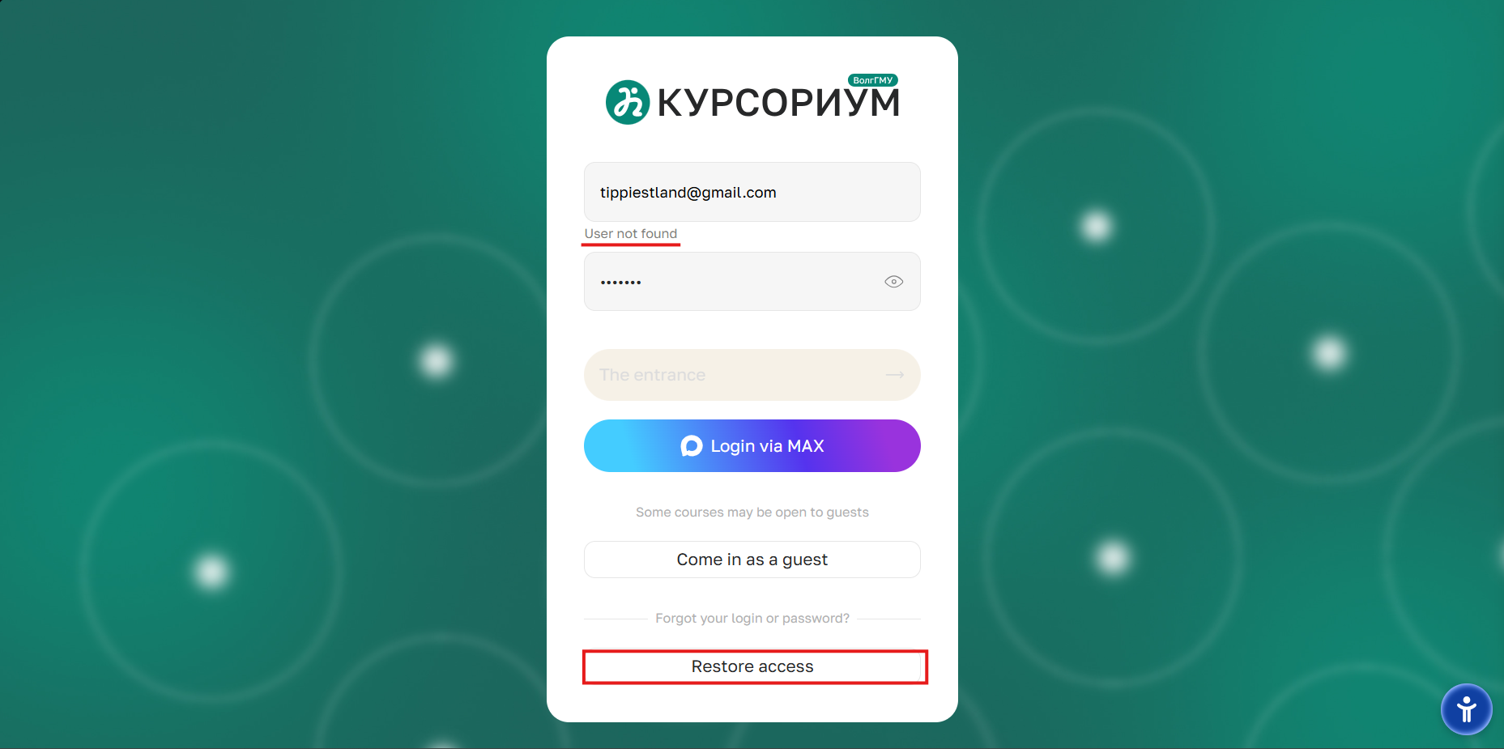
In the window that appears, select the "A student" option.
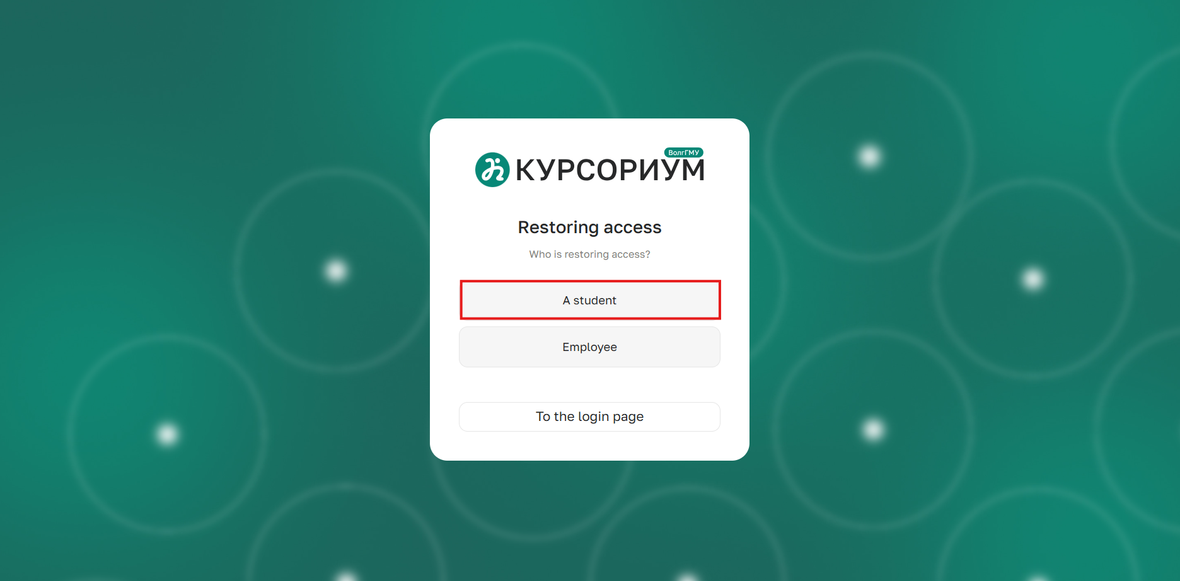
Enter your login or email address in the corresponding field. Click the "Check the user" button.
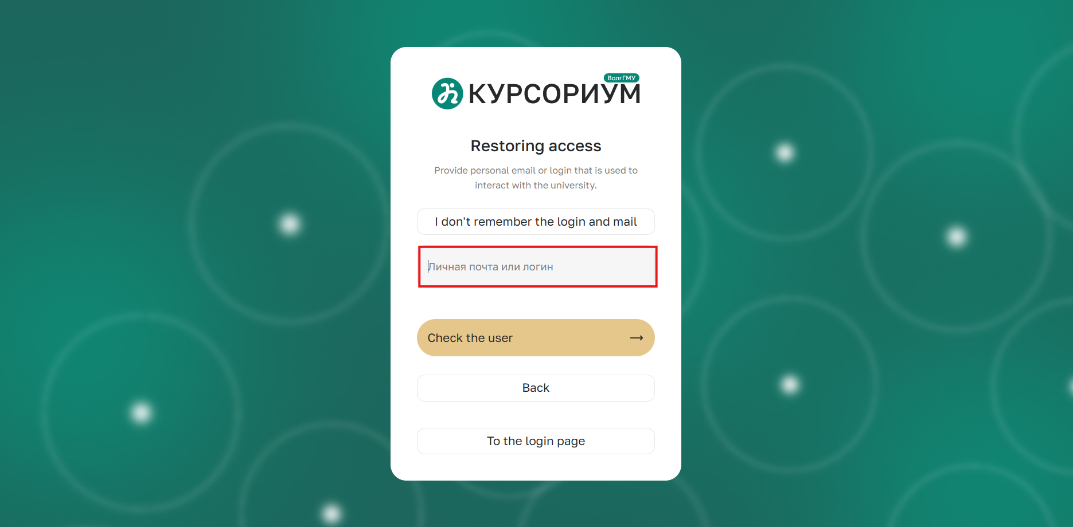
If the system does not find a user with the specified data, click the "I don't remember my login and email" link to proceed to the request form.
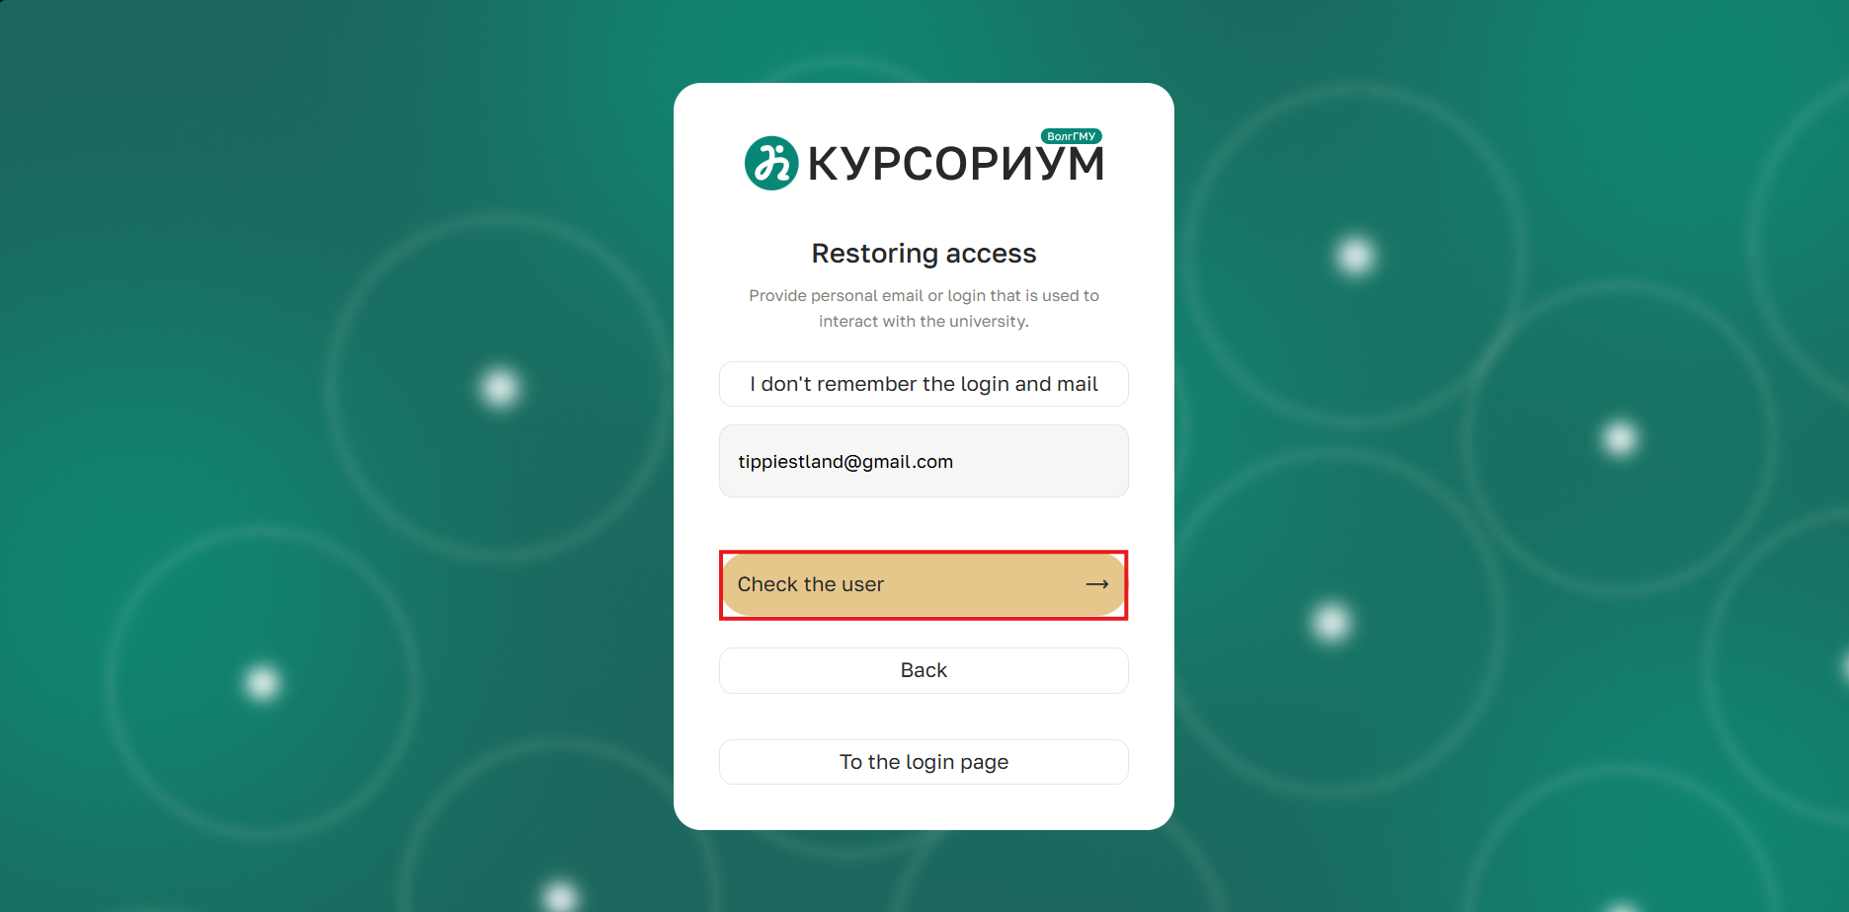
If the system does not find a user with the specified data, click the "I don't remember my login and email" link to proceed to the request form

Provide the following information on the page: full name, study group, student ID number, attach a photo with your face and student ID, and a backup email address.
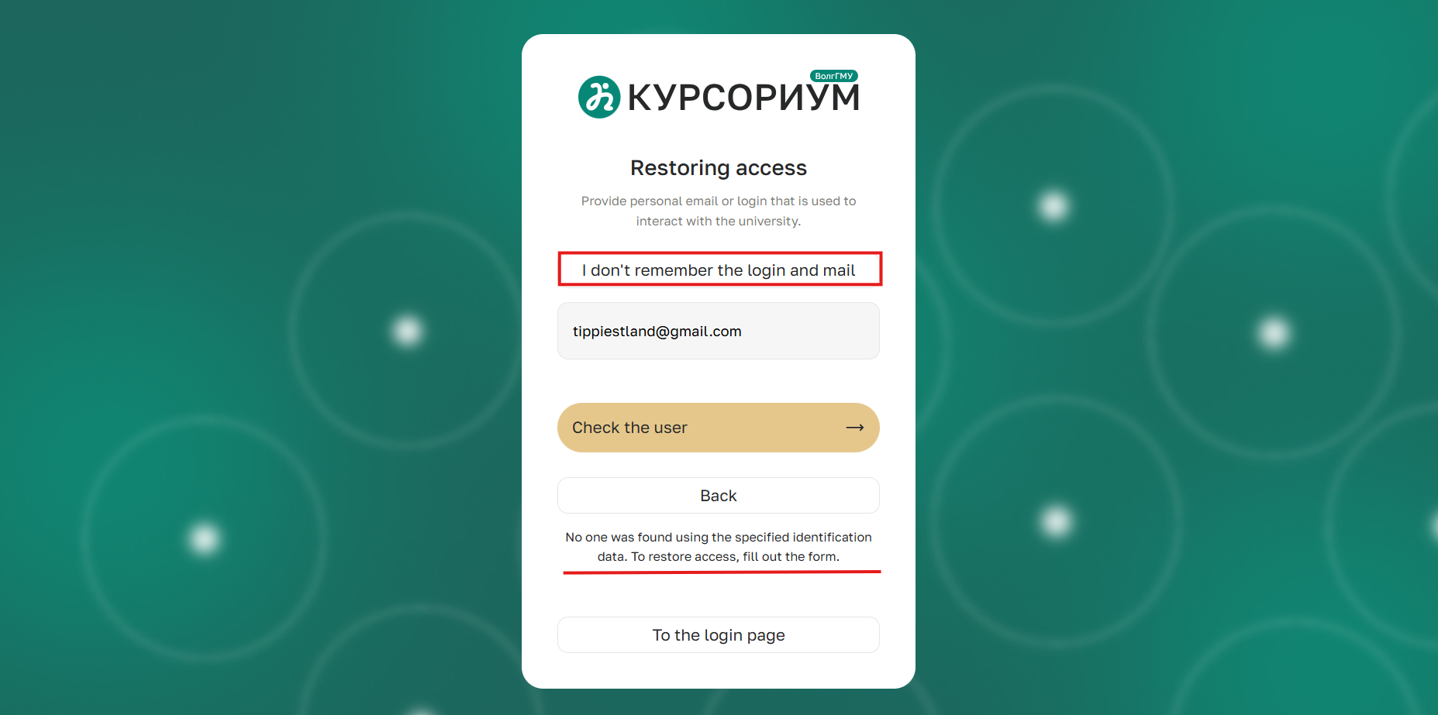
If you encounter the error "Student ID number not found", you will need to contact the dean's office in your application so that they can replace your student ID with a correct one. After that, you can resubmit the access recovery request.
