Date of creation: 16.10.2026

If you are unable to sign in to your account in the CURSORIUM system, follow the steps below. This guide is intended for students.

The guide is divided into two scenarios. Scenario A — if the system found you. Scenario B — if the system did not find you (you need to fill out an application).

Scenario A: User found

1. Entering your email address
In the email address field, enter your e-mail: students — personal email address; staff — corporate email address with the domain @volgmed.ru. After entering the address, click the «Check user» button.
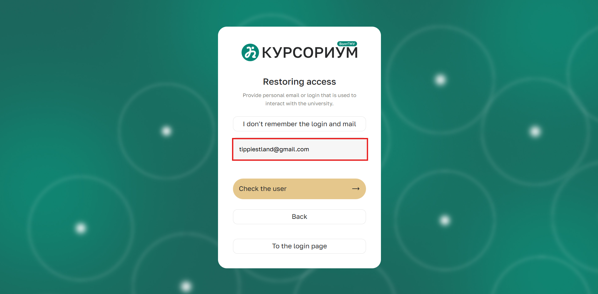
2. Confirmation of account availability
Wait for the system to confirm that the account exists. Once the corresponding window appears, go to your mailbox.
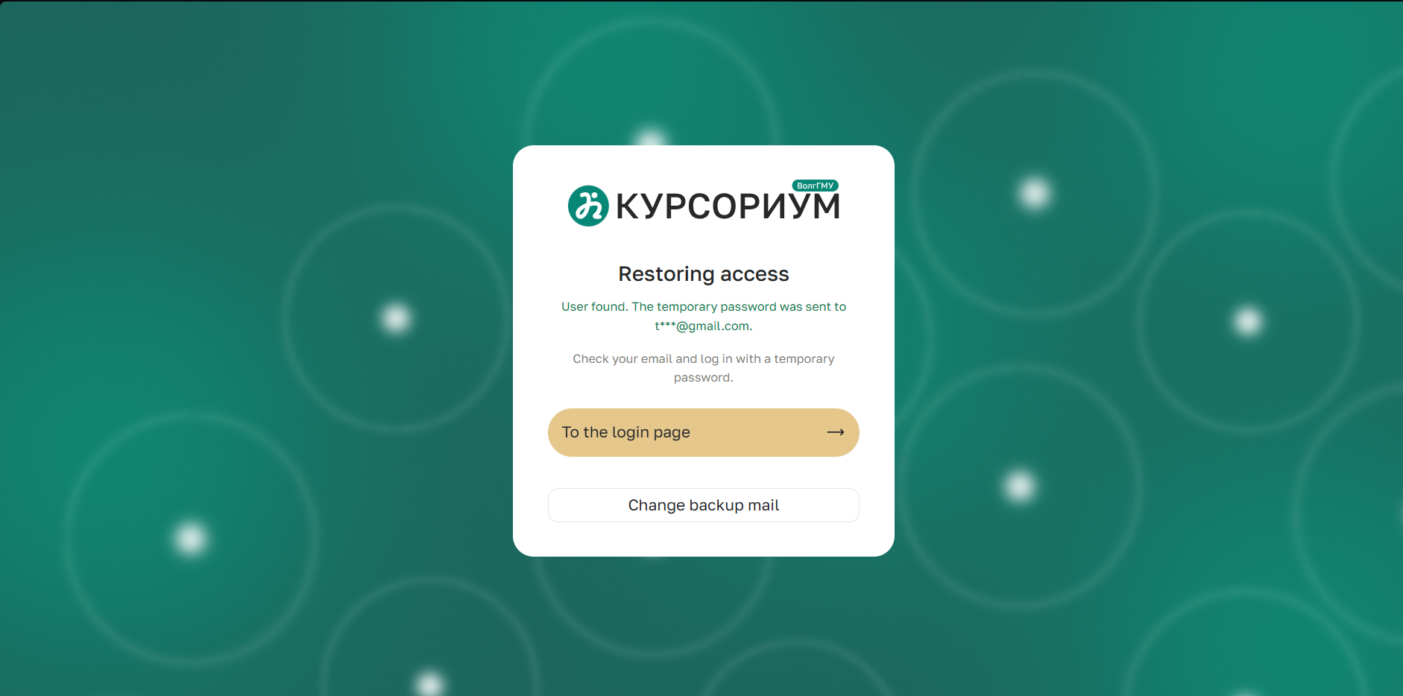
3. Opening the email from the «ZaBot» bot
In your mailbox, open the email sent by the «ZaBot» bot.
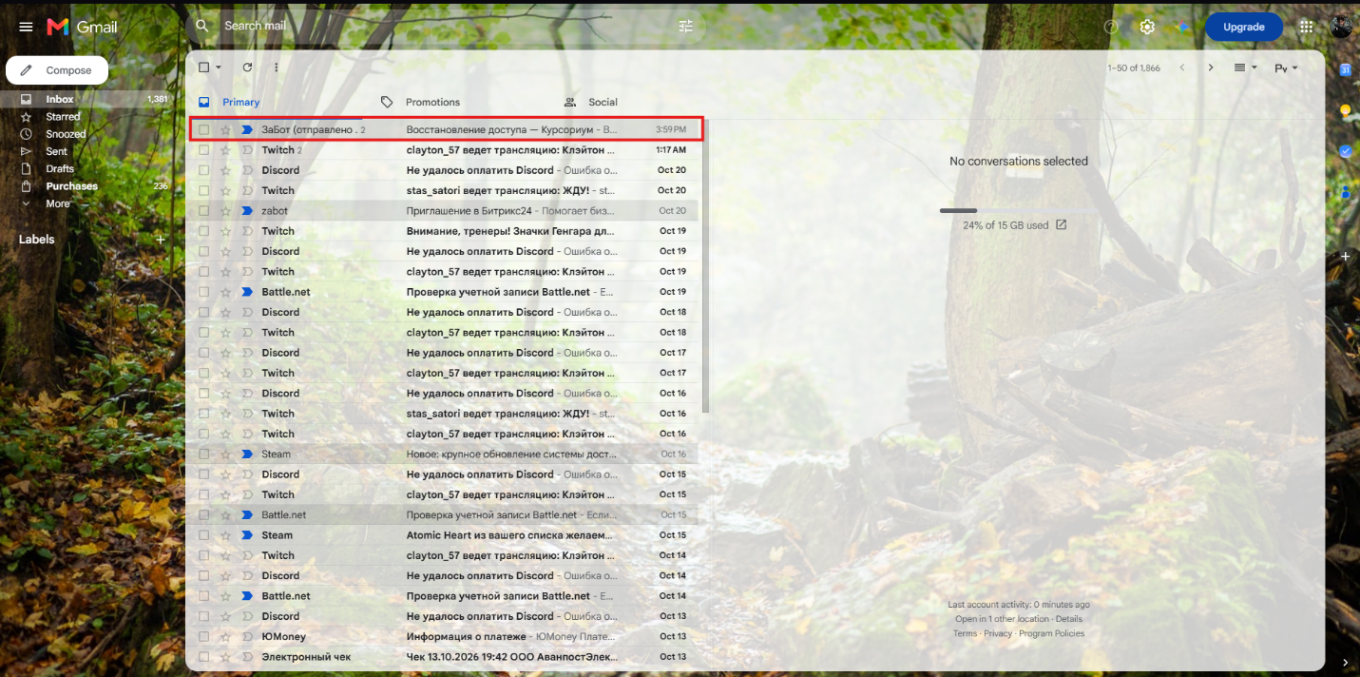
4. Copying the temporary password
Copy the temporary (one-time) password from the email. This password is valid for a single login; after a successful login, the system will require you to change it.
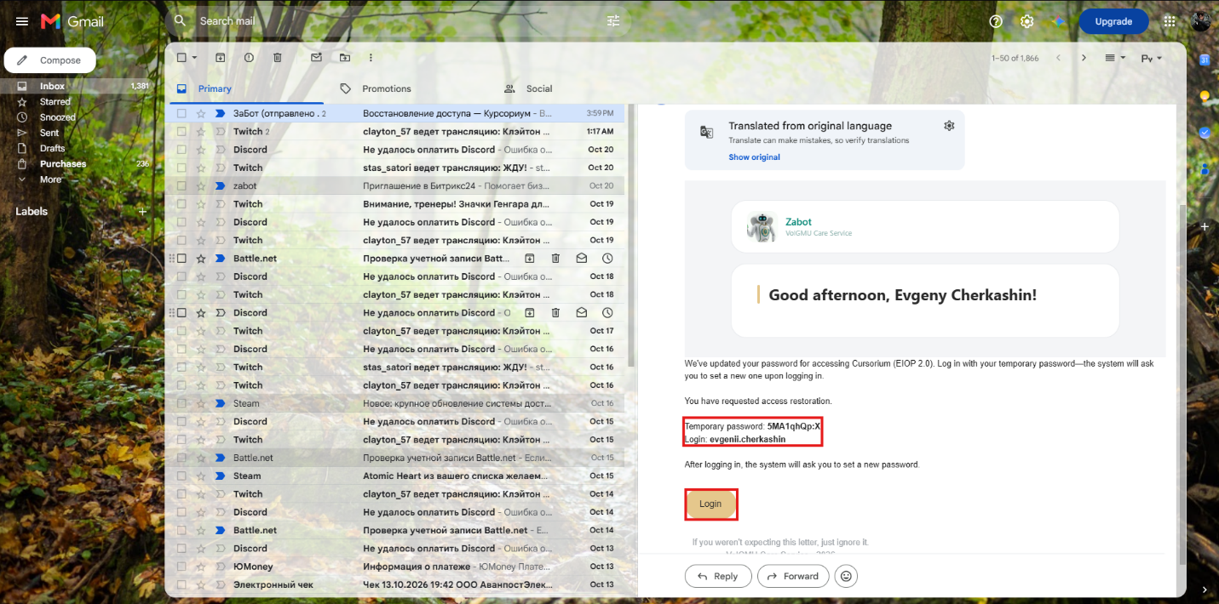
5. Returning to the sign-in page
Return to the «Cursorium» website and click the «Go to sign-in page» button.
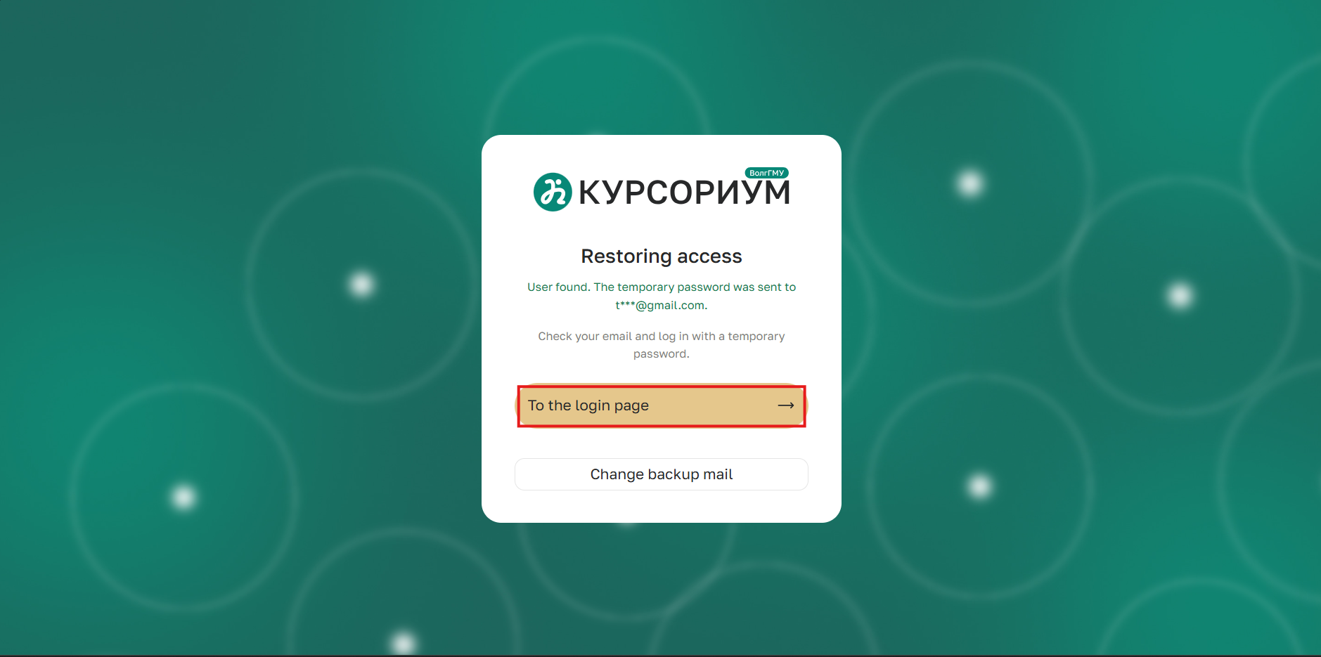
6. Entering the temporary password
In the login form, enter the one-time password you received in the password field and click the «Sign in» button.
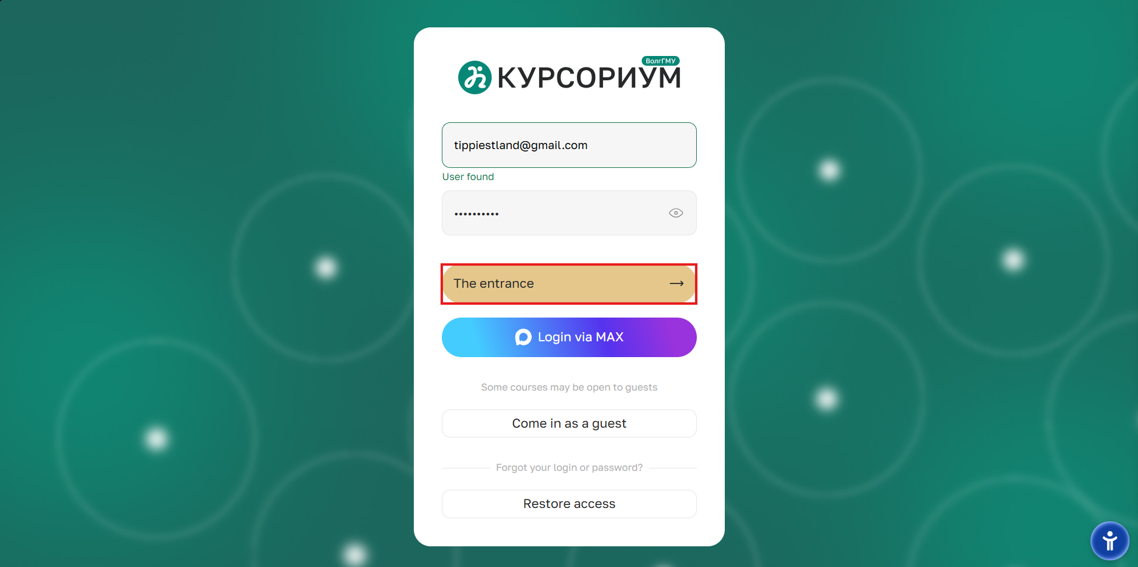
7. Changing the password
On the password change page, perform the following steps:
- enter the one-time password in the first field;
- enter a new password in the next two fields, following the password complexity requirements provided by the system;
- click the «Save» button.
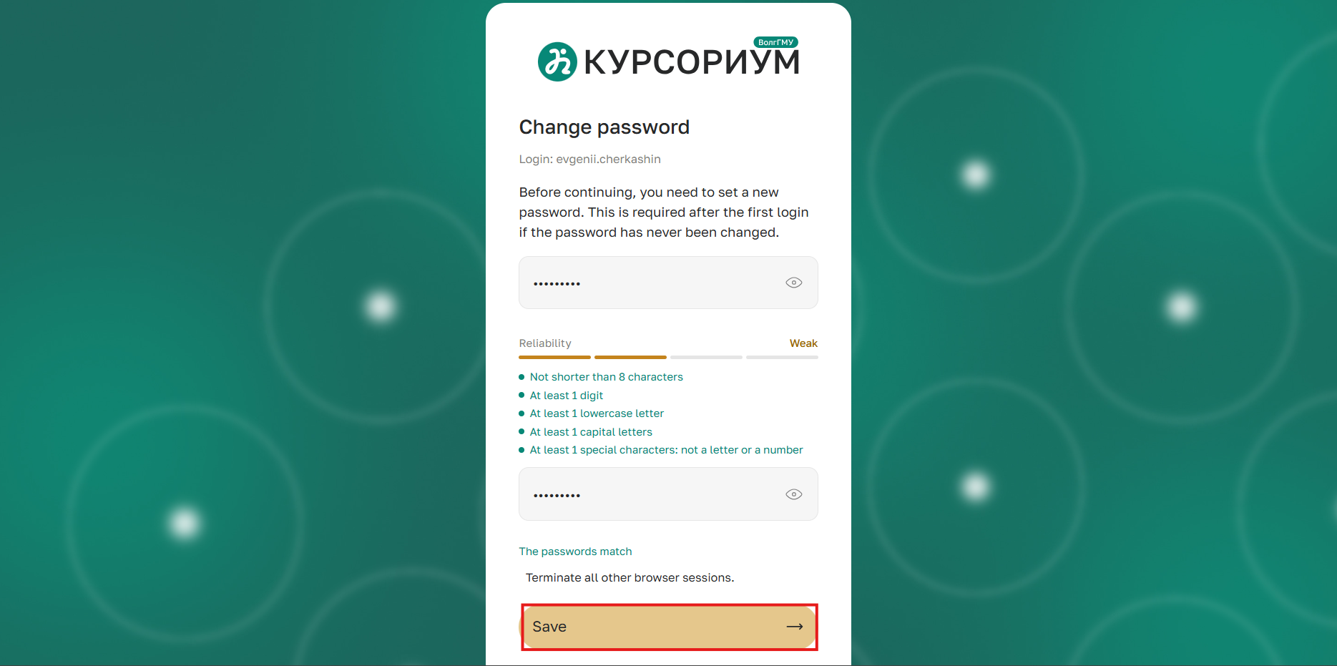
8. Authorization in the personal account
After confirming the password change, you will be logged in to your account on the «Cursorium» platform. In the future, use the permanent password you created to log in.
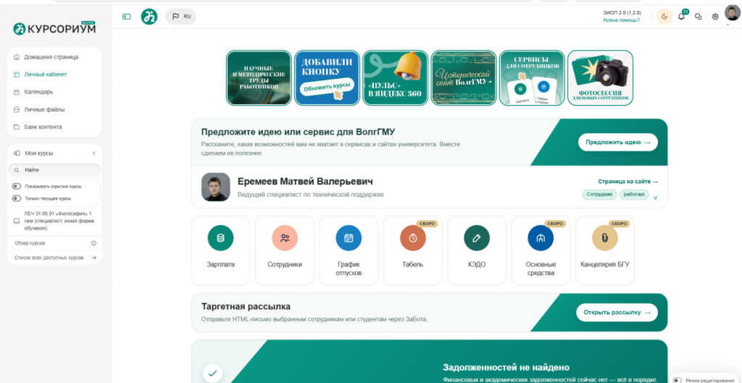

Scenario B: User not found

1. Restoring access
On the sign-in page, click the link «Restore access».
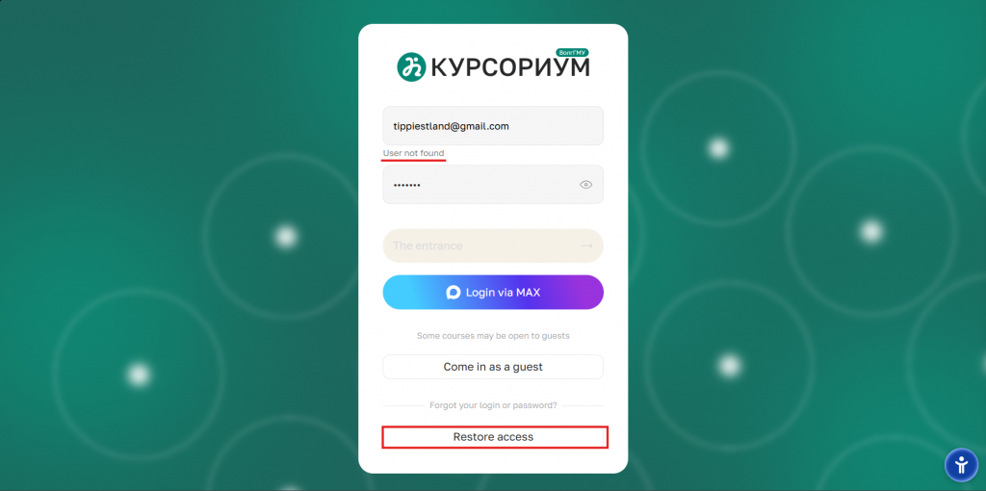
2. Selecting a role
In the window that appears, select the «Student» option.
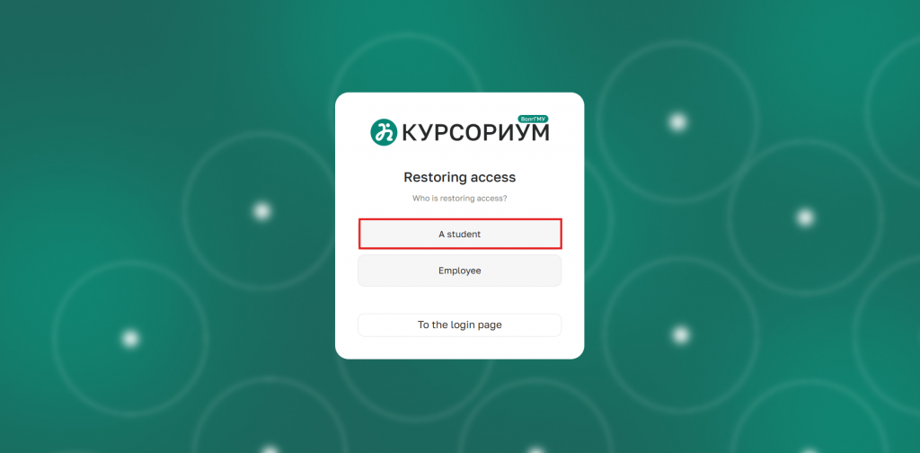
3. Entering your login or email
Enter your login or email address in the corresponding field. Click the «Check user» button.
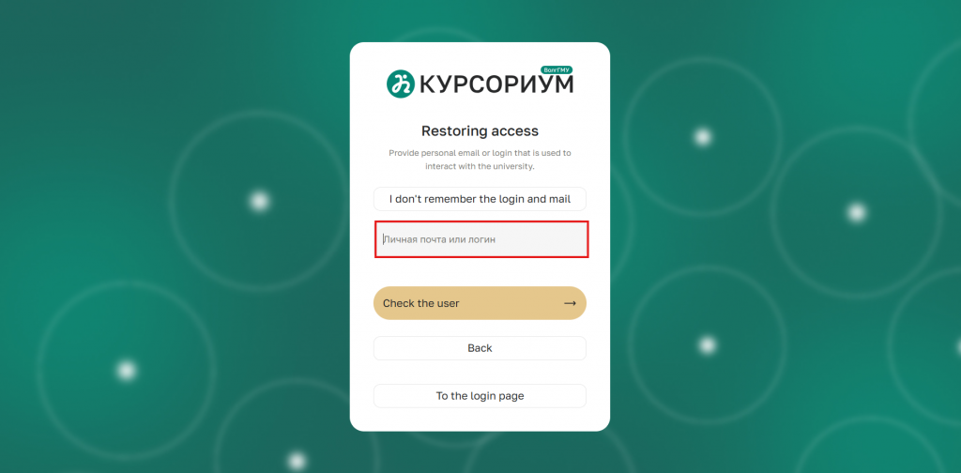
4. User not found
If the system does not find a user with the specified data, click the link «I don't remember my login and email» to proceed to the application form.
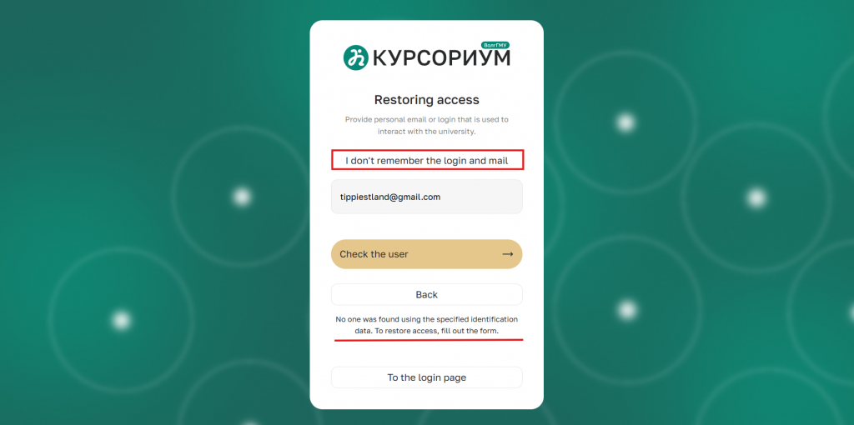
5. Filling out the application
Provide the following information on the page: full name, study group, student ID number, attach photos of yourself and your student ID, and specify a backup email address.
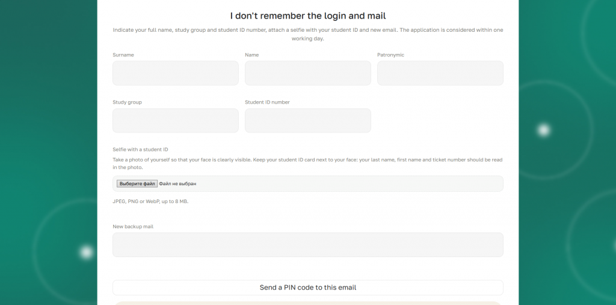
6. Error «Student ID number not found»
If you see the error «Student ID number not found», you need to contact your departmental dean's office. There, the specialists in the system must change the student ID number to the correct one. After that, you need to resubmit the access restoration request.
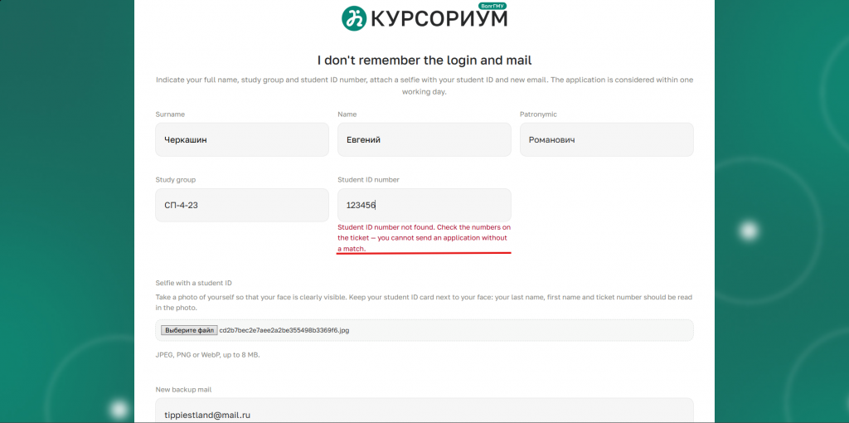
7. Error «Failed to send»
If you see the error «Failed to send. Please try again later»:
1. Check that the entered information is correct: the selfie with your student ID and the backup email address;
2. Contact your departmental dean's office so that specialists can check whether your email is entered in the 1C University PROF program.

